**Project Documentation**

**Cook Book : Your Virtual Kitchen Assisstant**

**1.Introduction:**

* **Project Title** : Cook Book : Your Virtual Kitchen Assistant
* **Team ID** : NM2025TMID30415
* **Team Leader Name** : V.Abitha
* **Mail id :** abithakavisamy2007@gmail.com
* **Team Member** : T.Akalya - **Mail id** : akalya112007@gmail.com
* **Team member** : T.Archanadevi **- Mail id** : archanadevit934@gmail.com
* **Team member** : C.Atchaya **- Mail id** : atchayachinnaiya@gmail.com
* **Team member** : M.Kishore Banu **- Mail id :** kishorebanu@gmail.com

# 2. Project Overview

* **Purpose:** SB Works connects clients and freelancers through project postings, bidding, and real-time communication.
* **Features:**
  + Project posting and bidding
  + Secure chat system
  + Feedback and review system
  + Admin control panel

# 3. Architecture

* **Frontend:** React.js with Bootstrap and Material UI
* **Backend:** Node.js and Express.js managing server logic and API endpoints
* **Database:** MongoDB stores user data, project information, applications, and chat messages

# 4. Setup Instructions

* **Prerequisites:**
  + Node.js
  + MongoDB
  + Git
  + React.js
  + Express.js **–** Mongoose **–** Visual Studio Code
* **Installation Steps:**

# Clone the repository git clone

# Install client dependencies cd client npm install

# Install server dependencies cd

../server npm install

# 5. Folder Structure

SB-Works/

|-- client/ # React frontend

|__components/ L__ pages/

|__ server/ # Node.js backend

|__routes/

|__ models/

|__ controllers/

# 6. Running the Application

* **Frontend:**

cd client

npm start

• **Backend:**

cd server npm start

* **Access:** Visit http://localhost:3000

# 7. API Documentation

* **User:**
  + /api/user/register
  + /api/user/login
* **Projects:**
  + /api/projects/create
  + /api/projects/:id • **Applications:** /api/apply
* **Chats:**
  + /api/chat/send **–** /api/chat/:userId

# 8. Authentication

* JWT-based authentication for secure login
* Middleware protects private routes

# 9. User Interface

* Landing Page
* Freelancer Dashboard
* Admin Panel
* Project Details Page

# 10. Testing

* Manual testing during milestones
* Tools: Postman, Chrome Dev Tools

1. **Screenshots or Demo**

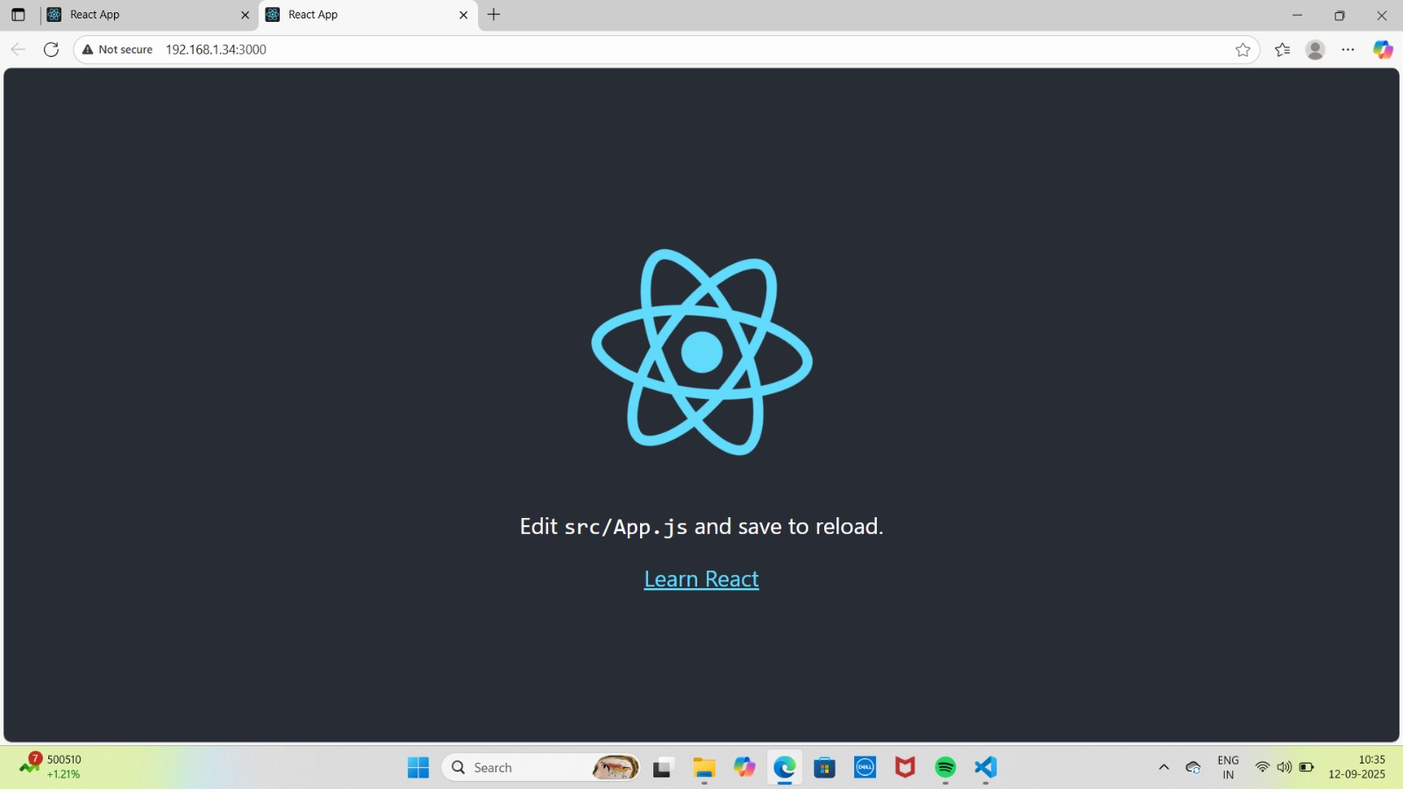 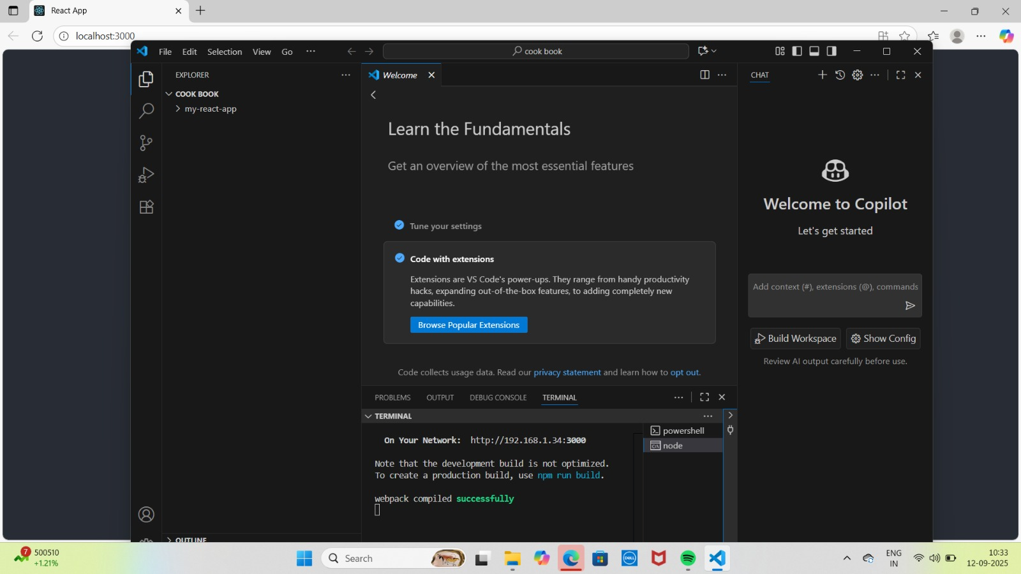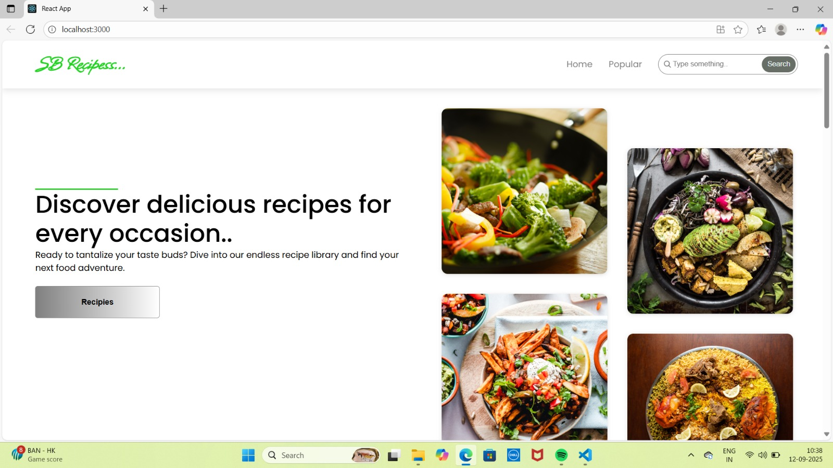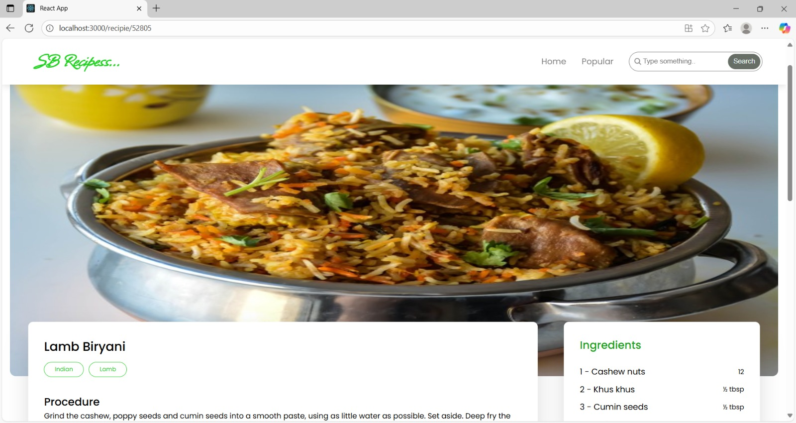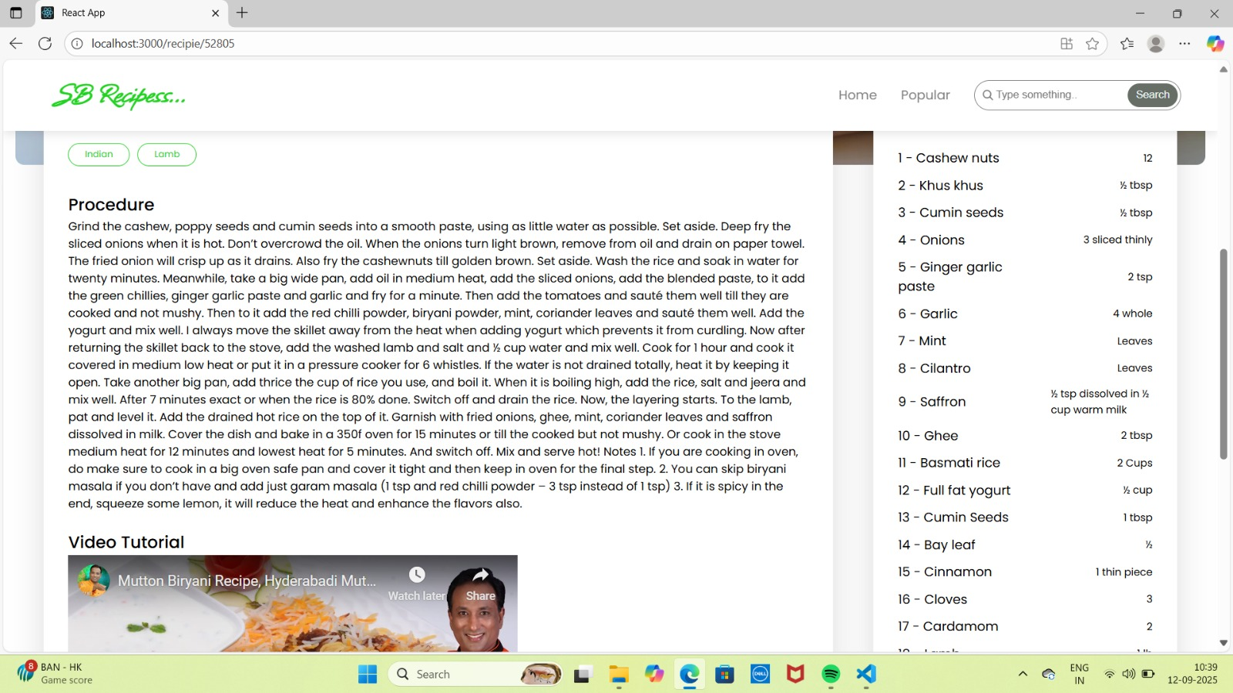

**12.Known Issues**

**Current Limitations:**

* Search feature is basic,lacks filters.
* API response times may cause delays.

**13.Future Enhancements**

* **User Authentication** : Allow users to save&share recipes.
* **Meal planner** : Help users plan their weekly meals.